General

MOHAIR ONE is a miniature transceiver designed for the construction competition, Konstruktionstävling 2009 published by ESR Sweden http://www.esr.se

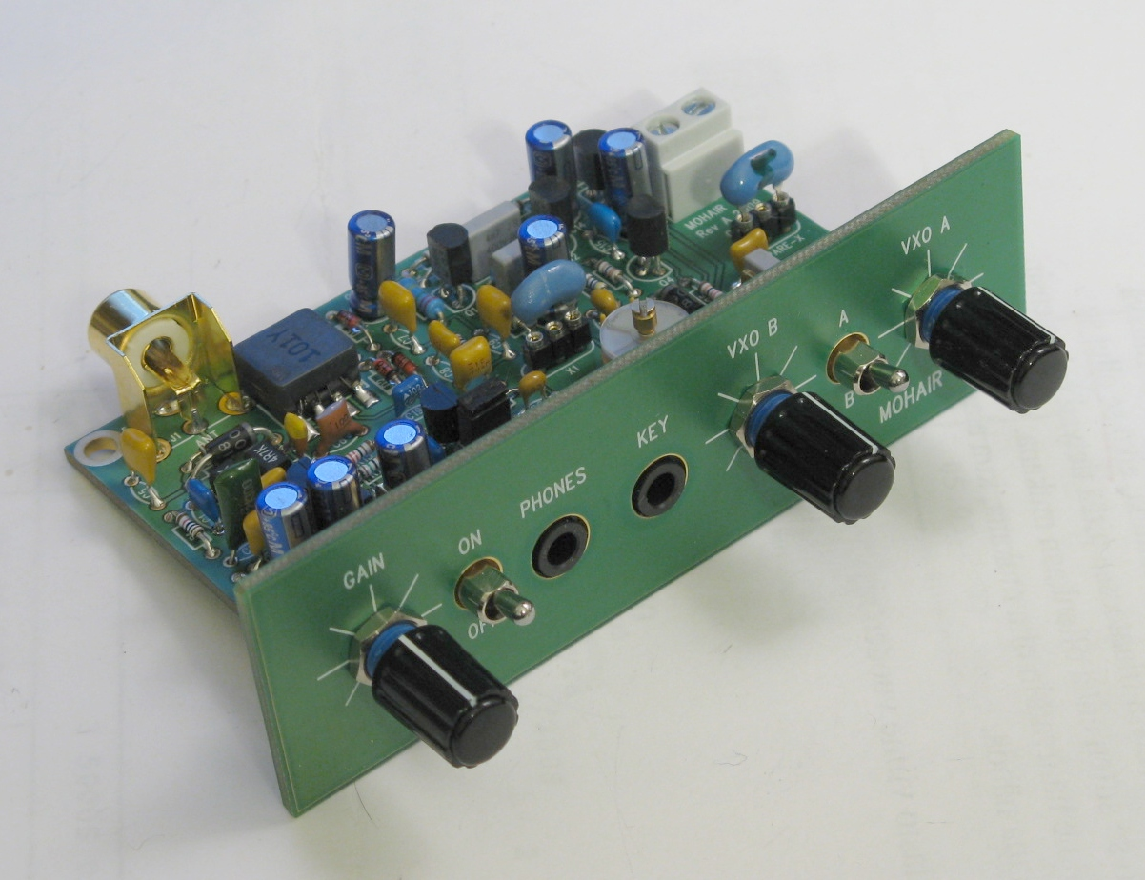
MOHAIR ONE miniature transceiver

MOHAIR ONE is a low power (QRPp) CW transceiver for 80 m band. It can be operated with a standard 9 volt battery (6LR61). It is very suitable for battery operation because of the low current consumption and the transceiver will maintain stable operation down to 5.2 volts. The supply voltage range is 5.2 V…15 V. The audio output is designed for headphones used in portable mp3 players. The RX can also drive a 8 ohm speaker with reasonable loudness. Additionally the audio amplifier can be modified with a single resistor for higher speaker output level. The performance of the transceiver is good in this class of QRP transceivers e.g. frequency stability, wide frequency tuning range, selectivity and wide supply voltage range. MOHAIR ONE can also be used for SSB listening with an optional ceramic resonator. The transceiver can also be used as a CW training buzzer by removing the TX jumper on the PCB, which disables the TX. The transceiver has been tested in real operation with several QSOs to Europe with good reports.

Typical characteristics
- Band coverage, 80 m amateur band
- Coarse frequency range 3.510 MHz to 3.590 MHz (with 3.58 MHz resonator)
- Coarse frequency range 3.630 MHz to 3.710 MHz (with 3.69 MHz resonator)
- Fine tuning range abt ±10 kHz with two separate VXO tuning knobs
- Double Side Band detector (CW, SSB)
- Sensitivity, minimum detectable signal (MDS) 0.4 uVrms (-115 dBm)
- Maximum undistorted antenna signal 7 mVrms (-30 dBm)
- Selectivity 500 Hz @ -6 dB
- RF output power 200 mW
- CW rise and fall time 2 ms
- Supply voltage range 5.2 VDC - 15 VDC
- Current consumption RX 10 mA, TX 80 mA
- No spurious AM broadcast RX response
- No RX hum or brum typically found in direct conversion receivers
Construction

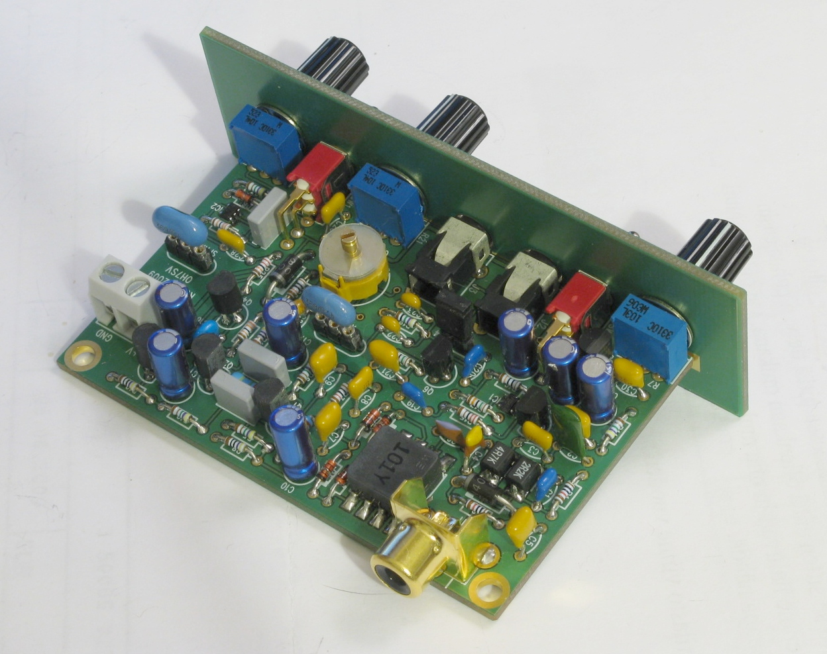
MOHAIR ONE rear view

The transceiver is constructed on a PCB board size of 80 mm x 50 mm and it is using thru-hole components and few SMD components. On the PCB there is a place for spare 3.69 MHz ceramic resonator which can be plugged in the VXO for SSB band reception. All the switches, connectors and the pots are installed on the PCB. No coils need to be wounded when constructing this transceiver.

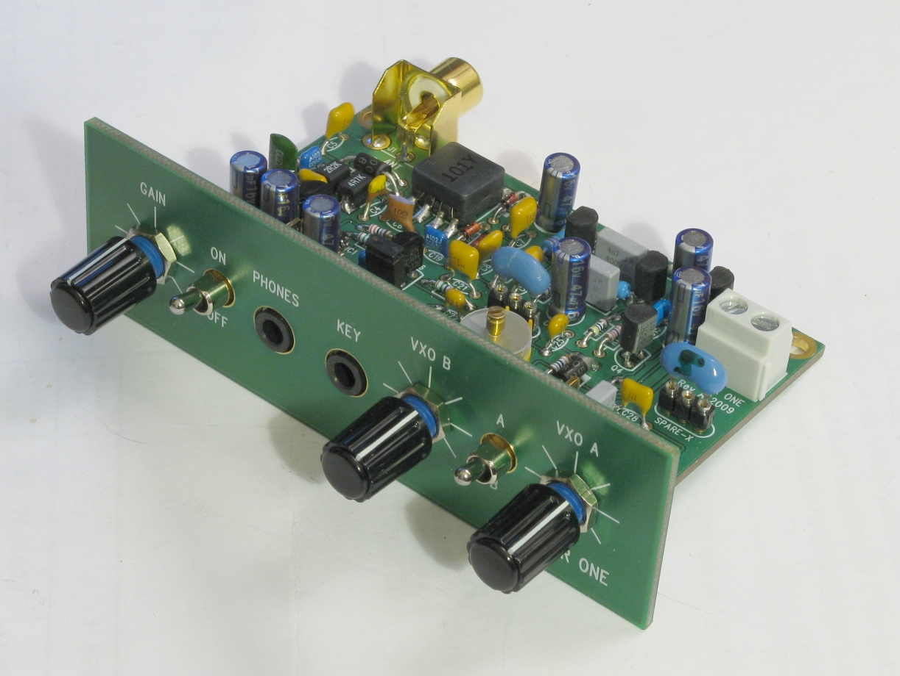

Switches
- Power ON/OFF
- VXO A, VXO B selection

Knobs
- AF Gain
- VXO A tuning
- VXO B tuning

Front connectors
- Phones
- CW key

Rear connectors
- Antenna
- Power supply
Principle of operation (Refer to the schematics and the block diagram)

The antenna signal is first fed to the low-pass filter which provides attenuation of unwanted bands. The signal is then fed to the balanced diode mixer which is designed so that it transforms impedance and provides voltage gain of 10 dB in conjunction with the mixer transformer. The mixer is using low level signal diodes 1N4148. The detected audio signal is then amplified 40 dB in the adjustable pre-amplifier and fed to the AF band pass Filter (BPF) which has a voltage gain of 30 dB. The center frequency of the AF band-pass filter is 650 Hz, thus optimized for CW operation. The filtered audio signal is buffered with a push-pull AF amplifier for a low impedance headphones. All the transistors have very high current gain (Hfe) minimum of 400. Total gain of the receiver is abt 80 dB.

MOHAIR ONE block diagram

The local oscillator, Variable Xtal Oscillator (VXO) is using a ceramic resonator with a nominal frequency of 3.58 MHz. The center frequency can be set with the trimmer capacitor C24 and the fine tuning is achieved by using a variable capacitance diode with a potentiometer. A standard rectifier diode (1N4005) is used as capacitance diode.

There are two VXO fine tuning pots which can be used flexibly. One VXO can be tuned to zero-beat of the listened station for TX use and the other VXO can be freely tuned during reception. The VXO is selected with a toggle switch.

The local oscillator signal is also fed to the RF power amplifier. It is keyed via the emitter which is grounded with a CW key. There is a RC circuit in the emitter which provided a sufficient CW rise and fall times. The output of the RF PA amplifier is then fed to the transmit-receive (T/R) switch which blocks the signal to RX during transmission. The T/R switch is also using a standard rectifier diode 1N4005.

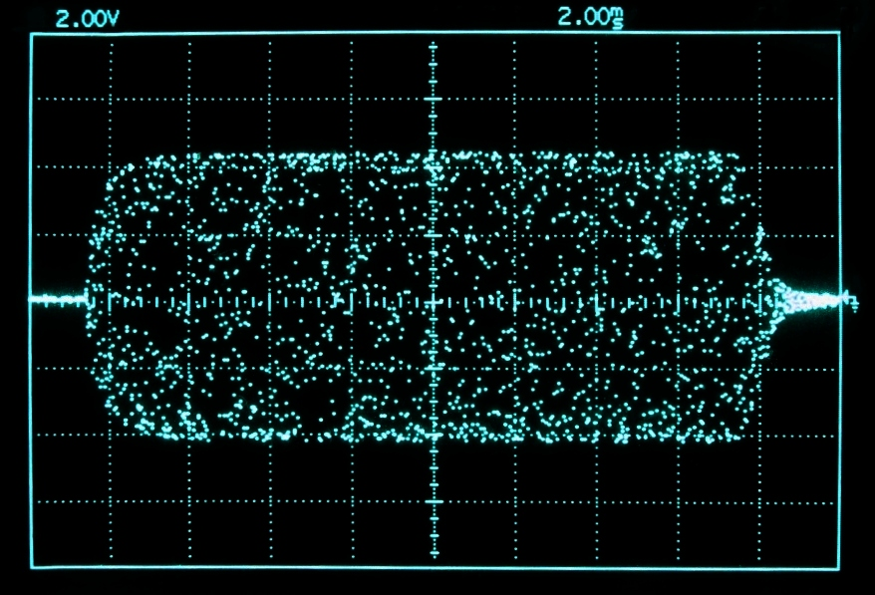
MOHAIR ONE CW keying shape
CW keying is shaped for abt 2 ms rise and fall times. It removes the klick and keying is “hard” enough for a low power QRP transmitter.
MOHAIR ONE RF filter
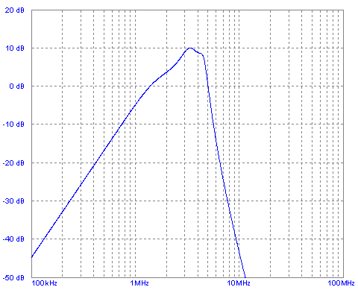

The RF filter is attenuating odd frequncy response and the AM proadcasts.
- Lowpass frequency corner 4.5 MHz
- High-pass frequency corner 2.5 MHz

MOHAIR ONE RX selectivity
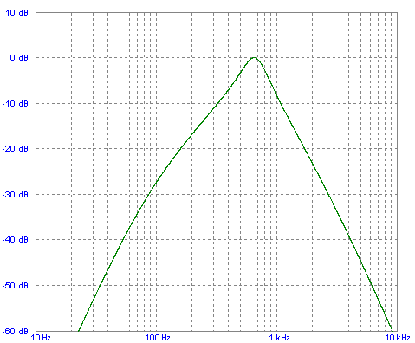

The audio band-pass filtering is opmized for CW operation. RX also suitable for SSB reception.
- Center frequency 650 Hz
- Bandwidth 500 Hz @ -6 dB

MOHAIR ONE PCB layout
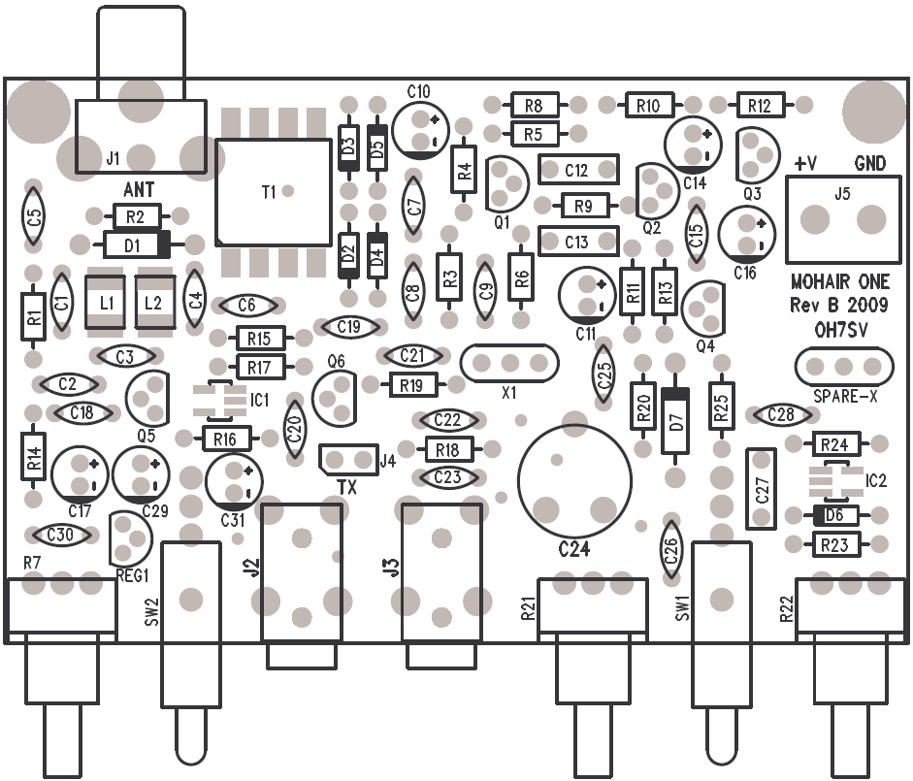

MOHAIR ONE front panel

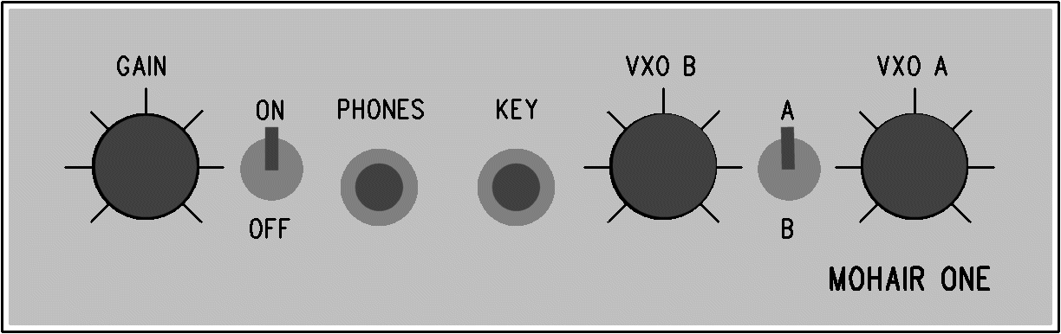

Disclaimer
MOHAIR ONE design, construction and all the material is copyright of Matti Hohtola. All rights reserved. Excluding other rights, the Experimenterande Svenska Radioamatörer (ESR) is granted the right to be the first publisher of the MOHAIR ONE transceiver.

Designer information
Name Matti Hohtola
Callsign OH7SV
Email
Homepage http://www.saunalahti.fi/hohtola
Address Lehdokkitie 8 B 26
01300 Vantaa
Finland

Appendices in electrical format

- Pictures (mohair-one-front-1.jpg)
(mohair-one-front-2.jpg)
(mohair-one-rear-1.jpg)
(mohair-one-rear-2.jpg)

- Block diagram (mohair-one-block-diagram.jpg)

- Shematics (mohair-one-schematics.jpg)

- PCB layout (mohair-one-pcb-layout.jpg)
(mohair-one-front-panel.jpg)

- Performance pix (mohair-one-rf-response.jpg)
(mohair-one-selectivity.jpg)
(mohair-one-keying-shape.jpg)

- Part list (mohair-one-part-list.xls)

- Live recording (sm7cbs-2009-03-06.mp3)

